Model Optimization and Tuning Phase

Date | 18 February 2026
Team ID | LTVIP2026TMIDS84978
Project Title | Advancing Nutrition Science through GeminiAI – NutriAssist AI
Maximum Marks | 10 Marks

Model Optimization and Tuning Phase
Model Optimization and Tuning Phase in NutriAssist AI focuses on improving the quality, safety, personalization accuracy, and nutritional relevance of AI-generated diet plans.
Since NutriAssist AI uses a pre-trained Gemini model, no neural network training or backpropagation is performed. Instead, optimization is achieved through:
Health-focused prompt engineering
Controlled generation parameter tuning
Structured output formattingand parameter tuning.

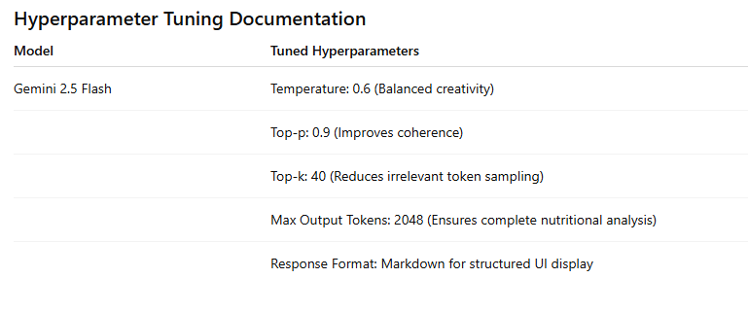

Final Model Selection Justification:

Final Model | Reasoning
Gemini Flash Lite (models/gemini-flash-latest) | Selected due to its fast inference speed, efficient resource usage, strong contextual understanding of structured health prompts, high-quality personalized nutrition generation, and seamless integration with real-time web applications like Streamlit.

